**Project Name: Vehicle Reservation System**

**Technical Design Document**

|  |  |  |  |
| --- | --- | --- | --- |
|  | **Prepared By / Last Updated By** | **Reviewed By** | **Approved By** |
| **Name** | Aravinthan P |  |  |
| **Role** | GenC |  |  |
| **Signature** | Aravinthan P |  |  |
| **Date** | 02/12/2019 |  |  |

# Introduction

## Purpose of this document

The purpose of this document is to document the technical design, component details and Database design for Vehicle Reservation System. This will also capture the scope, assumptions, risk, dependencies of this project.

## Project overview

The Vehicle Reservation System has admin login and member login/register .The member has to register in the app for authorized login. Based on the approval status by the admin the member can login in to the page. If the admin accepts then the member can login in to the page. If admin declines the member login, the member cannot login further. If the member logins, he can view the vehicle details and book the vehicle, payment by choosing the categories of vehicles displayed. Admin can edit the vehicle details at any time and can see the status of the vehicles.

# Solution Summary

## Scope

The scope of the vehicle reservation system is Login and Registration of user and admin, Admin will accept/ decline the members and will also update and delete the vehicle details.

## Assumptions

Weassume the following for development of our project

* Multiple members Login/Registration.
* Admin Login.
* Multiple Vehicles for different categories has reservation database.

## Dependencies

Member is dependent on admin for approving the registration.

## Risks

No Risk.

# Schematic Diagram

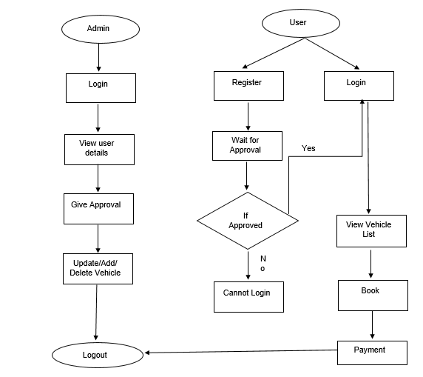

# System Design

## Proposed design

**1. Home Page**

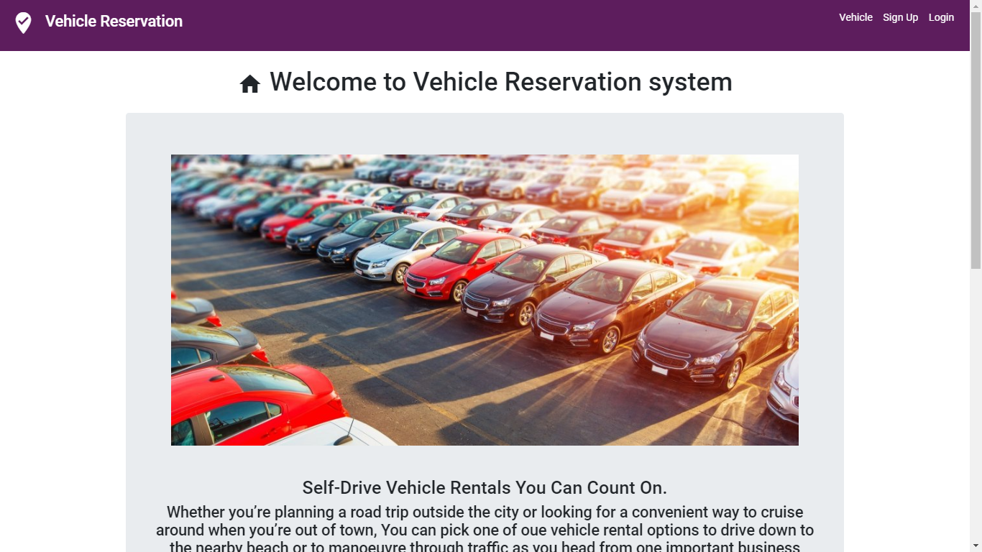

**2. Login Page**

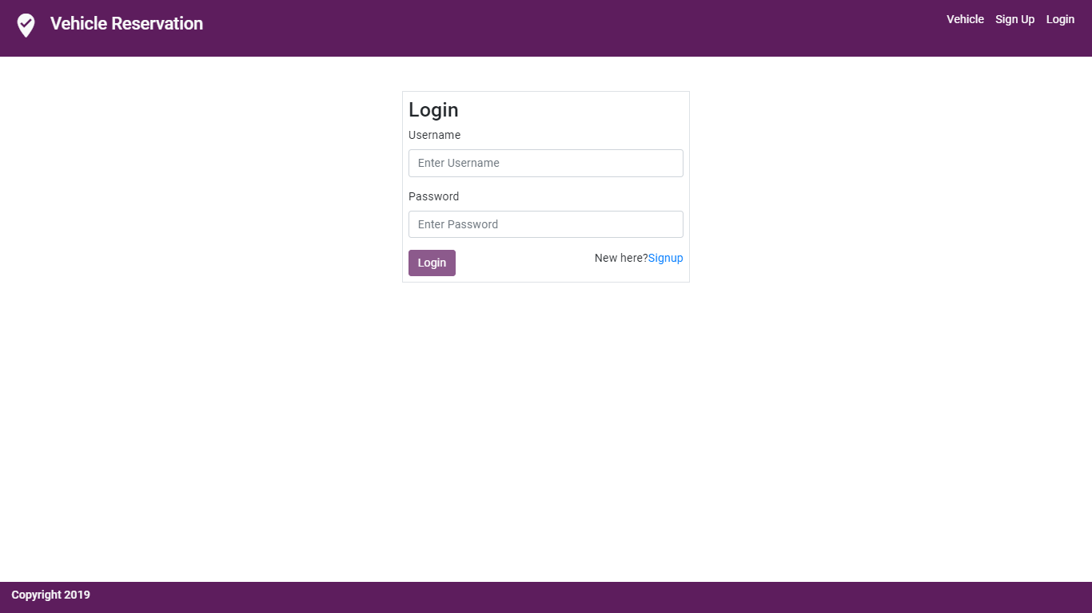

**3. Signup Page**

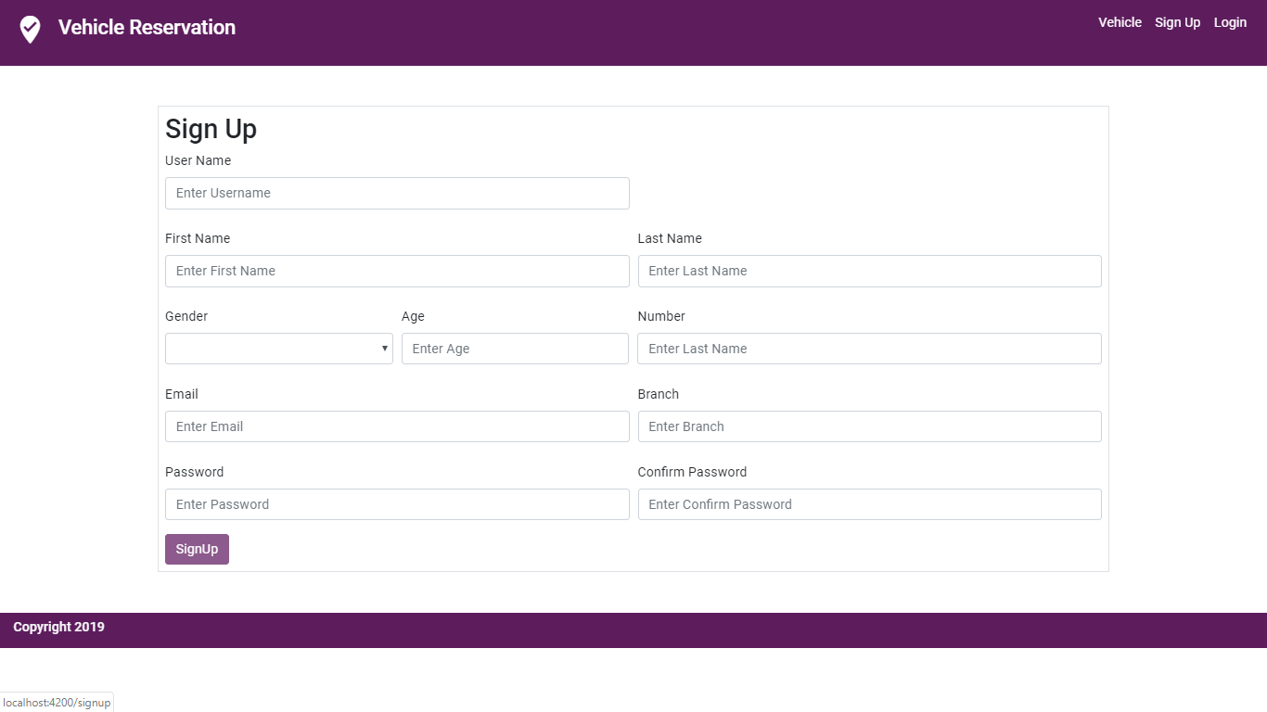

**4. Invalid User Page**

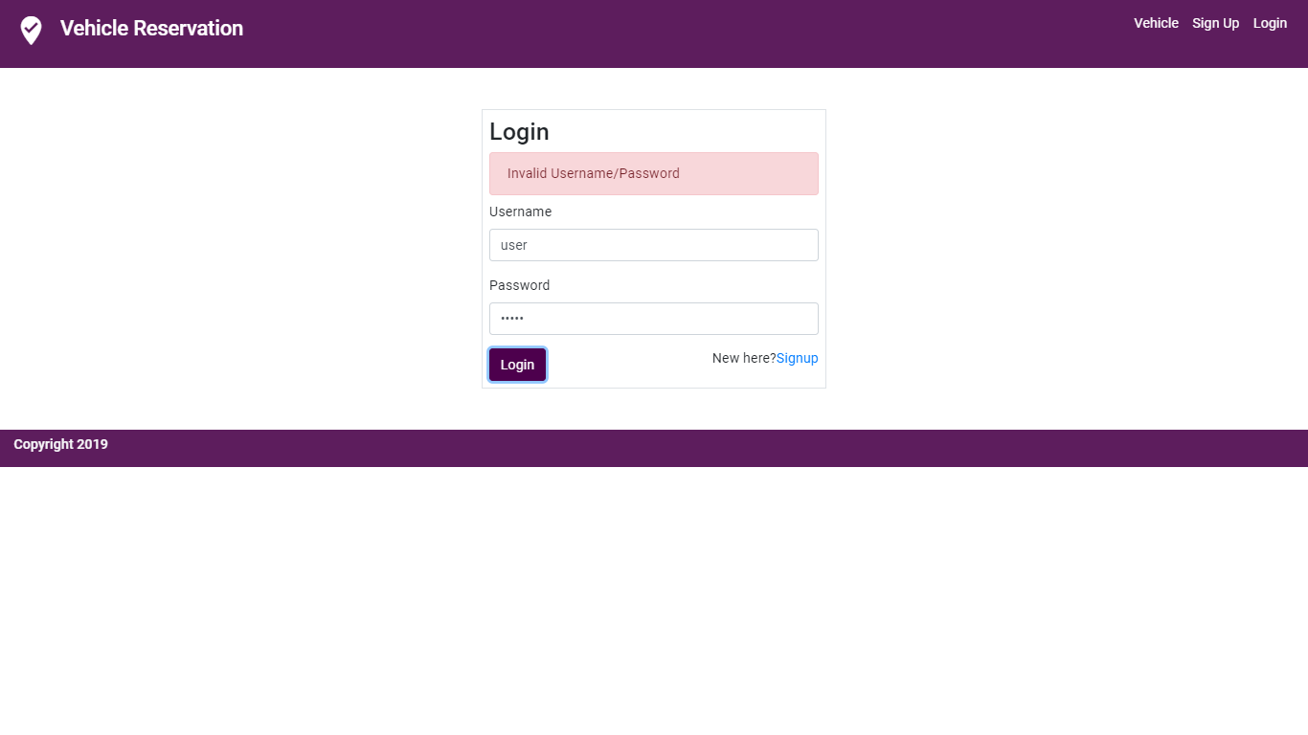

**5. Admin Vehicles List Page**

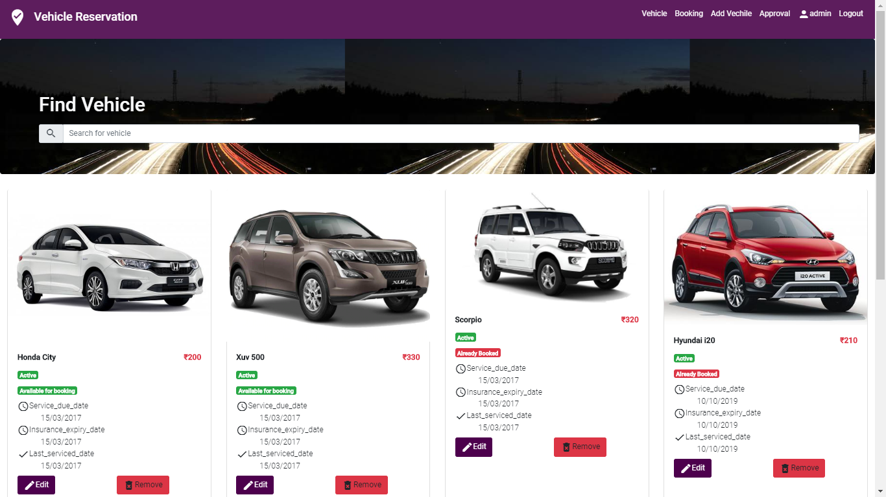

**6. To Modify Vehicle Page**

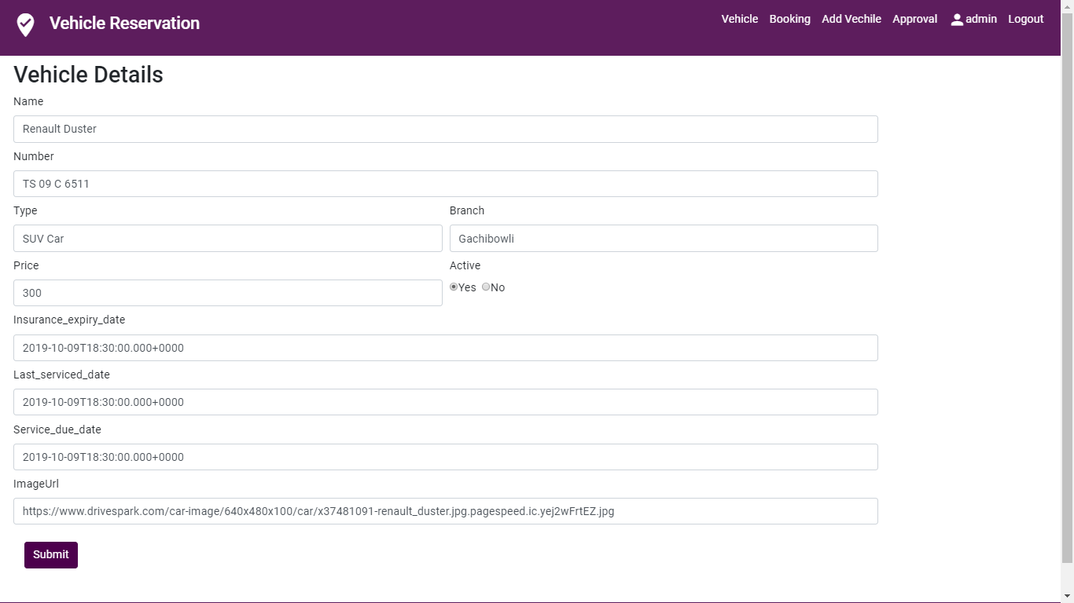

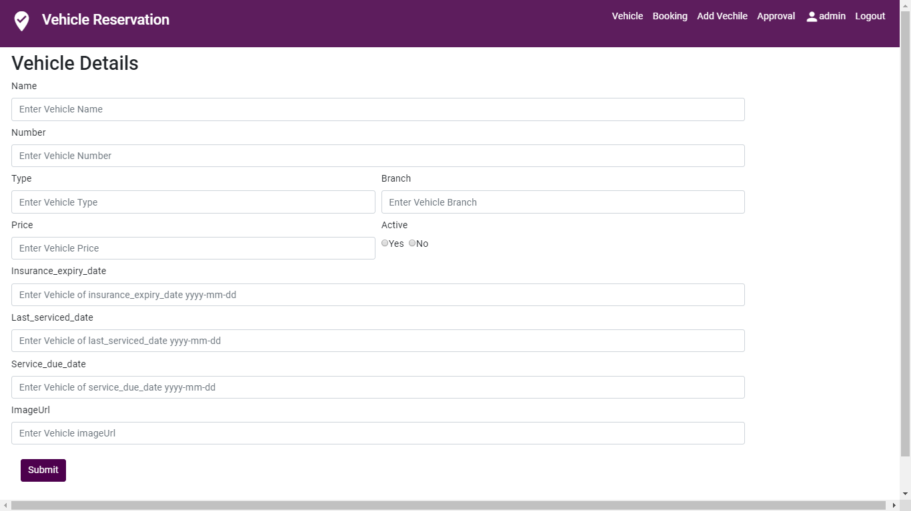**7. Adding Vehicles to the Vehicle List**

**8. Delete Vehicle Page**

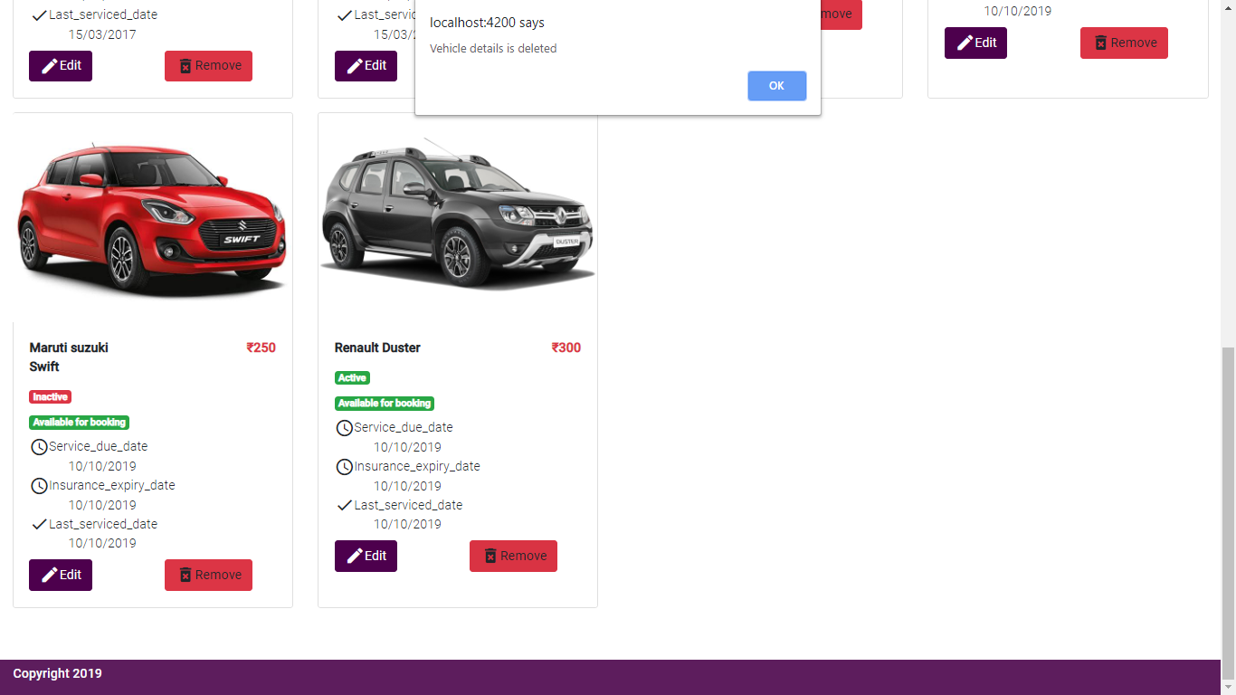

Two-Way Authentication

9. **New User Waits for login approval by Admin**

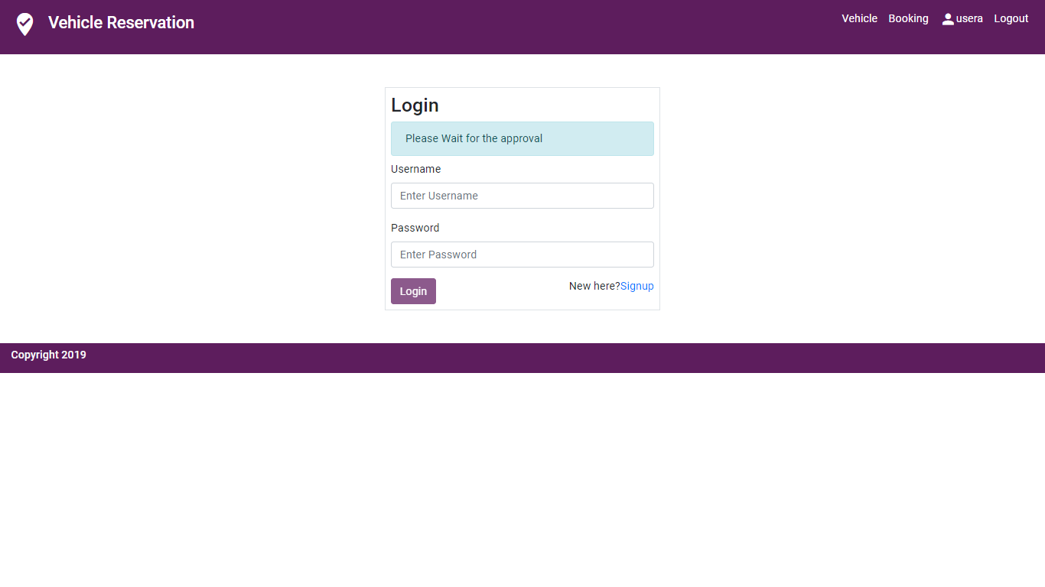

**10. Admin Status Approval**

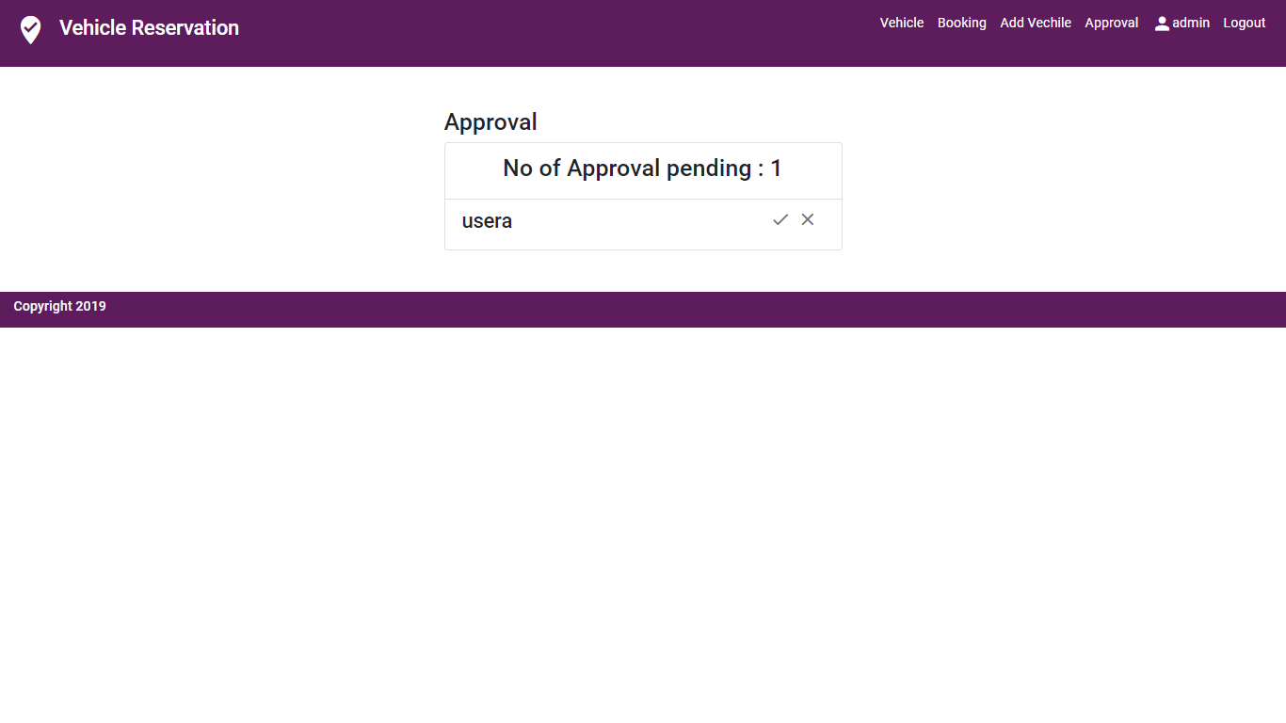

**11. The status information disappears after approval**

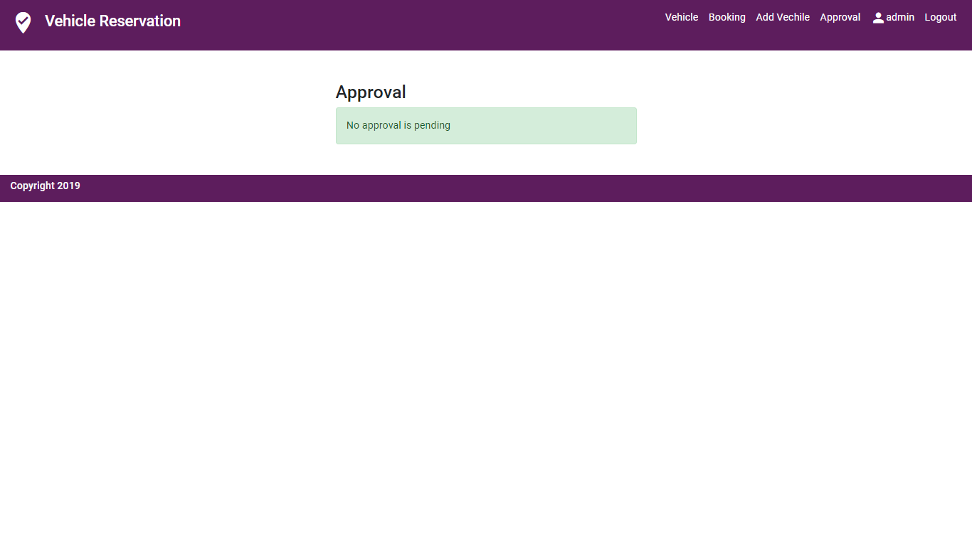

**12. User Login Page**

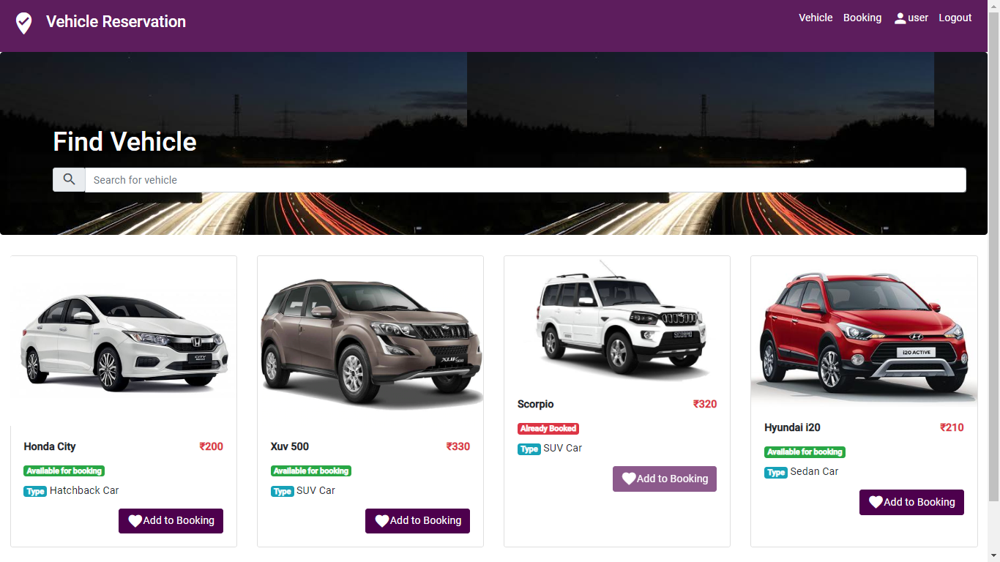

**13. User Booking Page**

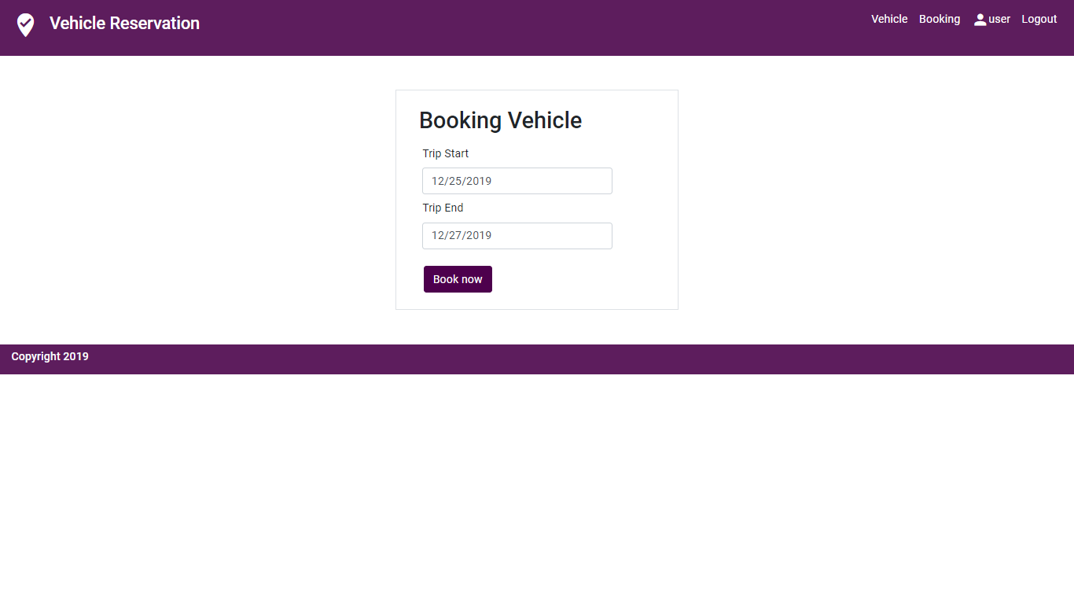

**14. Successful booking Page**

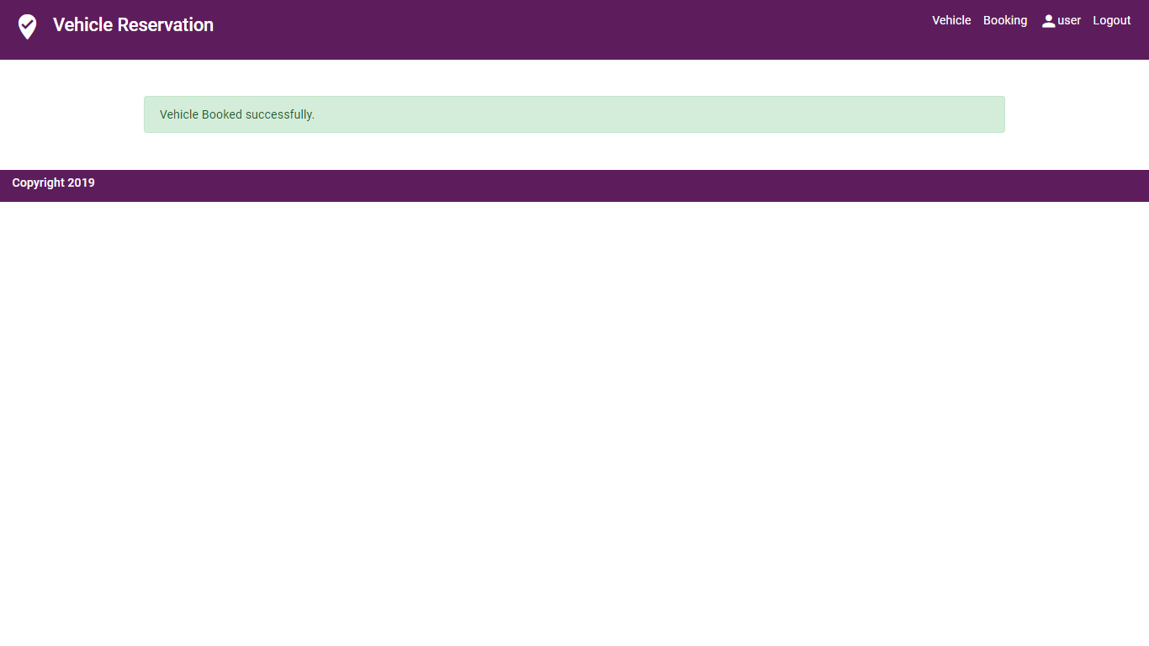

**15. Booking Details**

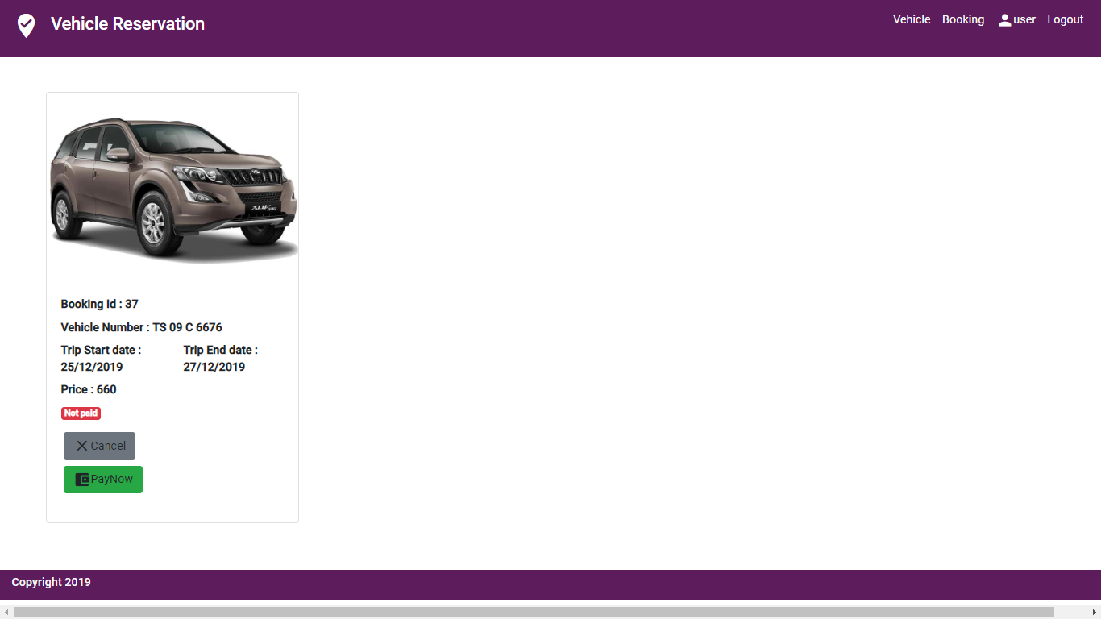

**16. Paying the booking**

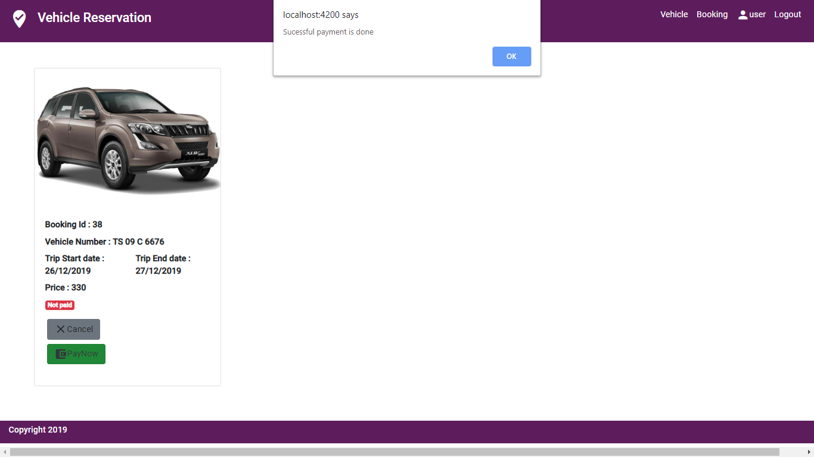

**17. User have a booking**

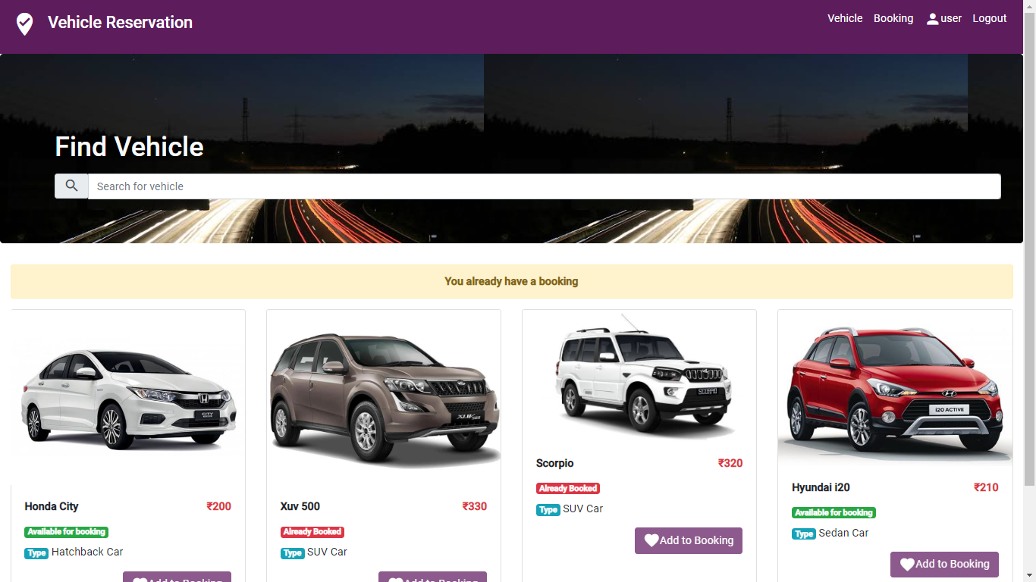

## Component inventory

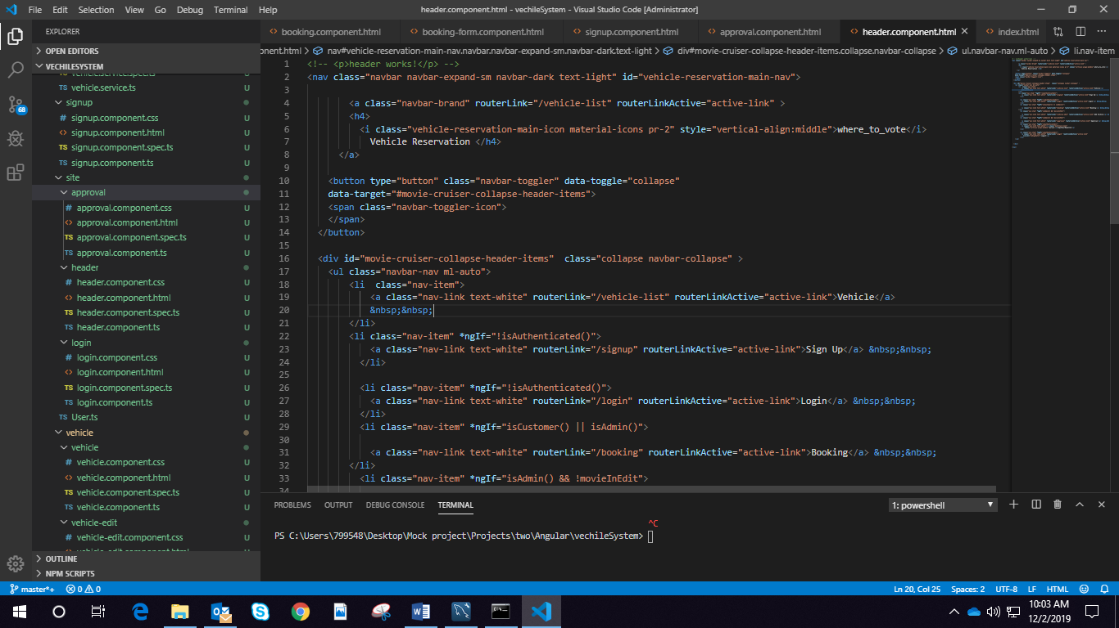

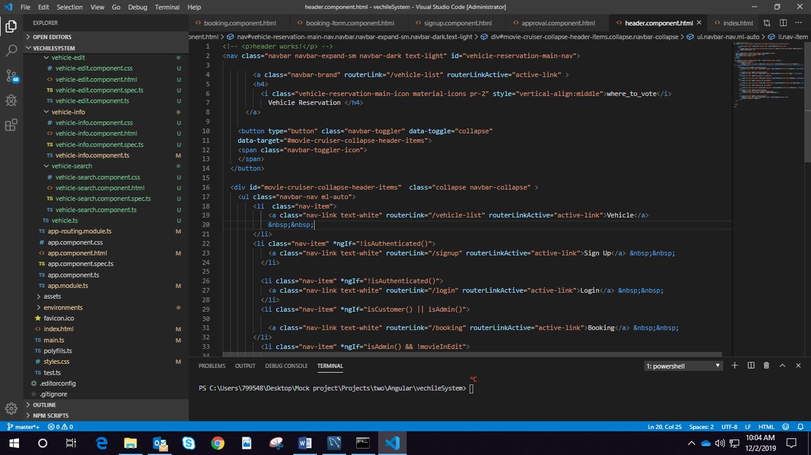

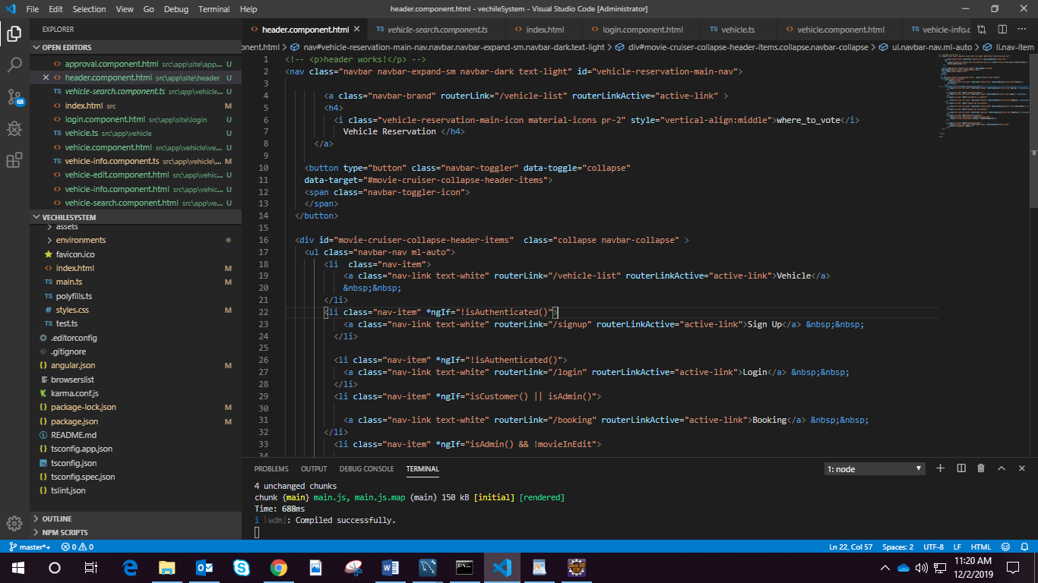

# Database Design

## Data Model

## Tables Structure

# **1. User Database**

|  |  |  |  |
| --- | --- | --- | --- |
| **Column Name** | **Data Type** | **Length** | **Nulls** |
| **Id** | **Int** | **(15)** | **Not Null** |
| **First Name** | **Varchar** | **(15)** | **Default** |
| **Last Name** | **Varchar** | **(15)** | **Default** |
| **Age** | **Int** | **(5)** | **Default** |
| **Gender** | **Varchar** | **(10)** | **Default** |
| **Contact** | **Int** | **(11)** | **Default** |
| **Email** | **Varchar** | **(30)** | **Default** |
| **Branch** | **Varchar** | **(20)** | **Default** |
| **Status** | **Boolean** | **--** | **Not Null** |
| **Password** | **Varchar** | **(200)** | **Not Null** |
| **User Name** | **Varchar** | **(10)** | **Not Null** |

**2. Vehicle Database**

|  |  |  |  |
| --- | --- | --- | --- |
| **Column Name** | **Data Type** | **Length** | **Nulls** |
| **Vehicle Number** | **Varchar** | **(15)** | **Not Null** |
| **Vehicle Type** | **Varchar** | **(15)** | **Not Null** |
| **Insurance Expiry Date** | **Date** | **--** | **Not Null** |
| **Service Date** | **Date** | **--** | **Default** |
| **Due Date** | **Date** | **--** | **Default** |
| **Vehicle Image** | **Varchar** | **(200)** | **Default** |
| **Branch** | **Varchar** | **(10)** | **Default** |
| **Price** | **Decimal** | **(6,2)** | **Default** |
| **Status** | **Boolean** | **--** | **Default** |

**3. User Role Database**

|  |  |  |  |
| --- | --- | --- | --- |
| **Column Name** | **Datatypes** | **Length** | **Nulls** |
| **User Role ID** | **Integer** | **-** | **Not Null** |
| **User Id (FK)** | **Integer** | **-** | **Not Null** |
| **Role Id(FK)** | **Integer** | **-** | **Not Null** |

4**. Role Database**

|  |  |  |  |
| --- | --- | --- | --- |
| **Column Name** | **Datatypes** | **Length** | **Nulls** |
| **Role id** | **Integer** | **-** | **Not Null** |
| **Role Name** | **Varchar** | **(15)** | **Not Null** |

5**. Booking Database**

|  |  |  |  |
| --- | --- | --- | --- |
| **Column Name** | **Datatypes** | **Length** | **Nulls** |
| **Booking ID** | **Integer** | **-** | **Not Null** |
| **Start Date** | **Date** | **-** | **Not Null** |
| **End Date** | **Date** | **-** | **Not Null** |
| **Paid** | **Boolean** | **-** | **Default** |
| **User Id (FK)** | **Integer** | **-** | **Not Null** |
| **Integer Id (FK)** | **Integer** | **-** | **Not Null** |

# Appendices

## Glossary

|  |  |
| --- | --- |
| **Acronyms** | **Definitions** |
|  |  |

## Other

# Terms & Conditions

Interns shall be solely responsible for all its acts and omissions under this program. Interns will comply at all times with all applicable laws. Interns shall not use Cognizant’s name, logo and trademark in any promotional materials or other communications with third parties without the prior written consent of Cognizant. Any materials used by interns in relation to program will not infringe the copyrights, trademarks, patents, trade secrets or other intellectual property rights, privacy or similar rights of any person or entity. Interns agrees not to post, draw, make, display any content that is threatening, libelous, obscene, defamatory, abusive, pornographic, or advocates/encourages any conduct that could constitute a criminal offence or give rise to any civil liability. Cognizant its associates’ personal details including but not limited to name, address, contact number shall not be shared or forwarded to any third party, without prior written consent of Cognizant, its associates. All intellectual property provided by Cognizant, as part of program shall be owned exclusively by Cognizant. Intern shall indemnify, defend and indemnify Cognizant its associates, officers, directors from and against any claims, demands, loss, damage, liability, causes of action, judgments, or costs and expenses of every nature (including attorney’s fees and expenses) incurred by Cognizant based on any claim that any breach of terms and conditions of this program

# Change Log

*Please note that this table needs to be maintained even if a Configuration Management tool is used.*

|  |  |  |  |  |
| --- | --- | --- | --- | --- |
| Version Number | Changes made | | | |
| V<n.n> | *<If the change details are not explicitly documented in the table below, reference should be provided here>* | | | |
| Page no | Changed by | Effective date | Changes effected |
|  |  |  |  |
|  |  |  |  |
|  |  |  |  |
|  |  |  |  |